MAIN PAGE HEADER

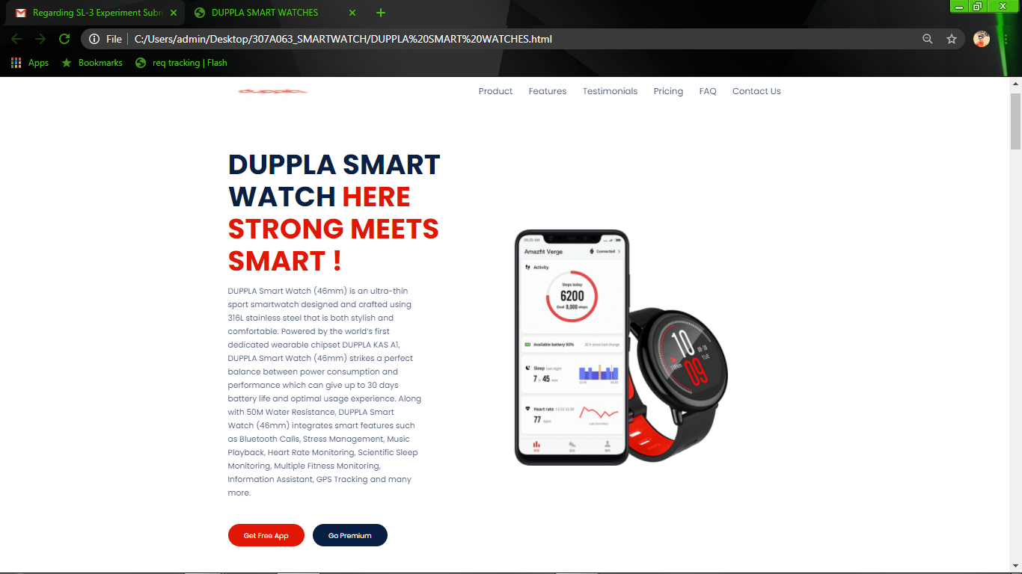

ON CLICKING PRODUCT TAB

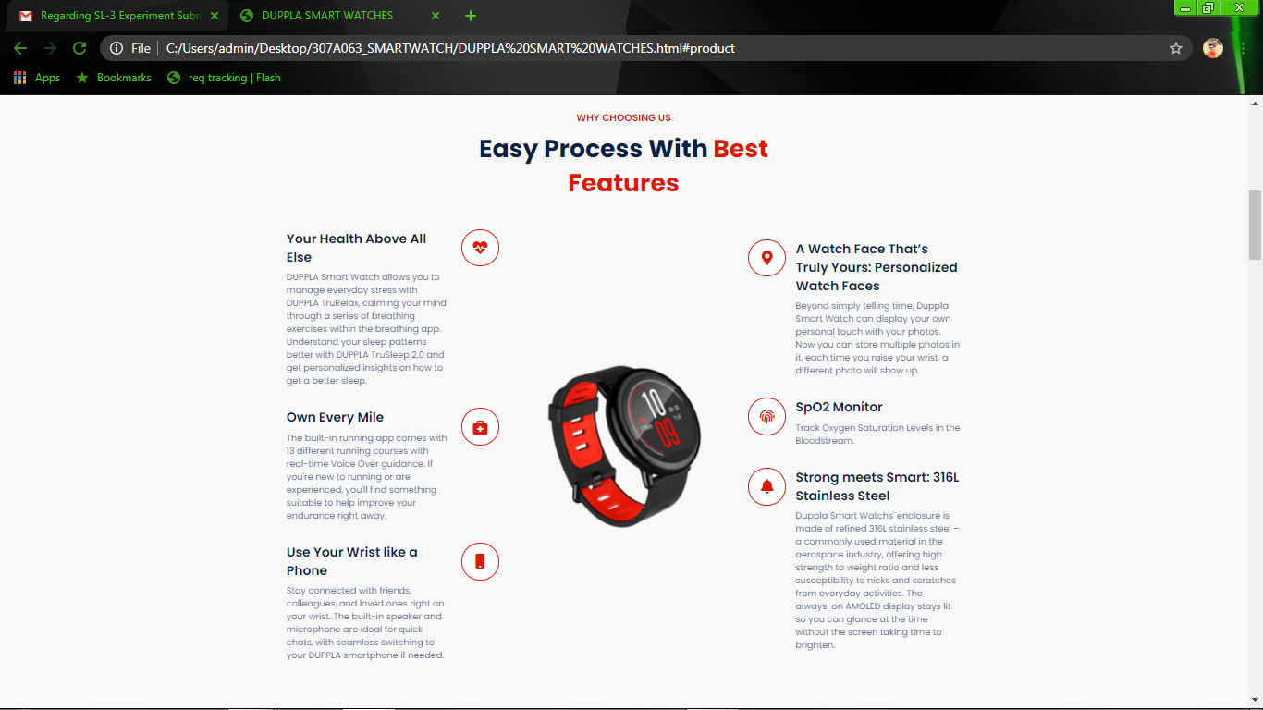

ON CLICKING FEATURES TAB

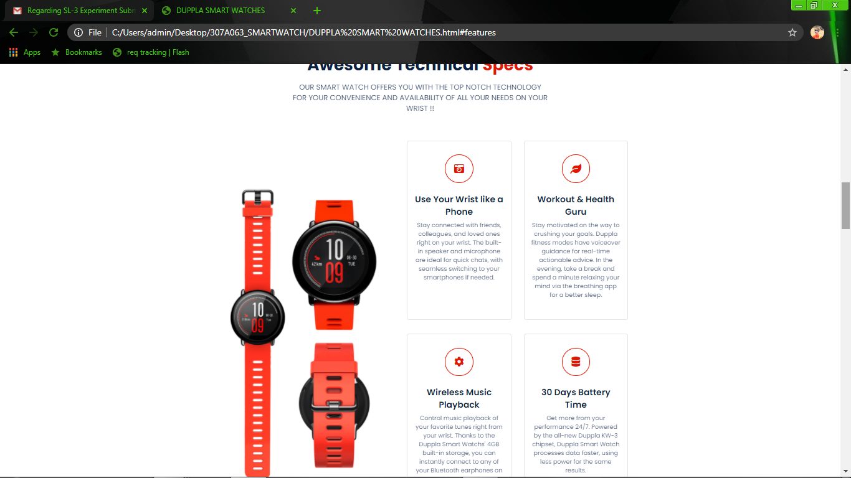

ON CLICKING TESTIMONIALS TAB FOR CUSTOMER REVIEWS

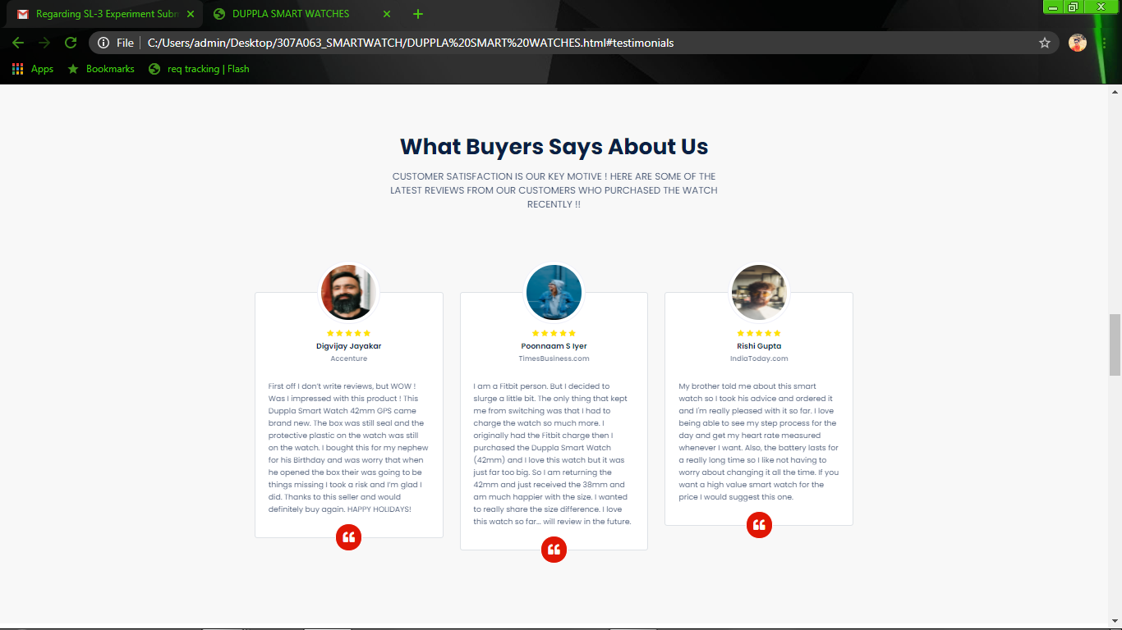

ON CLICKING PRICING TAB

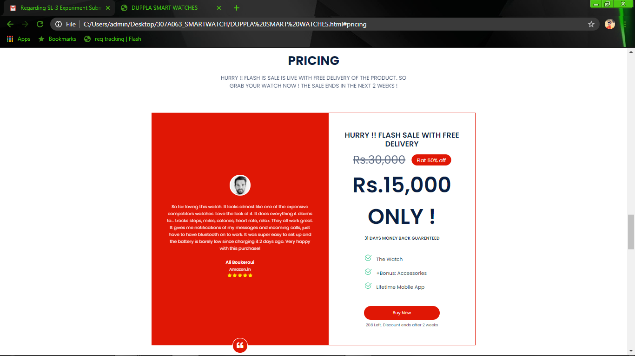

ON CLICKING FAQ’S TAB

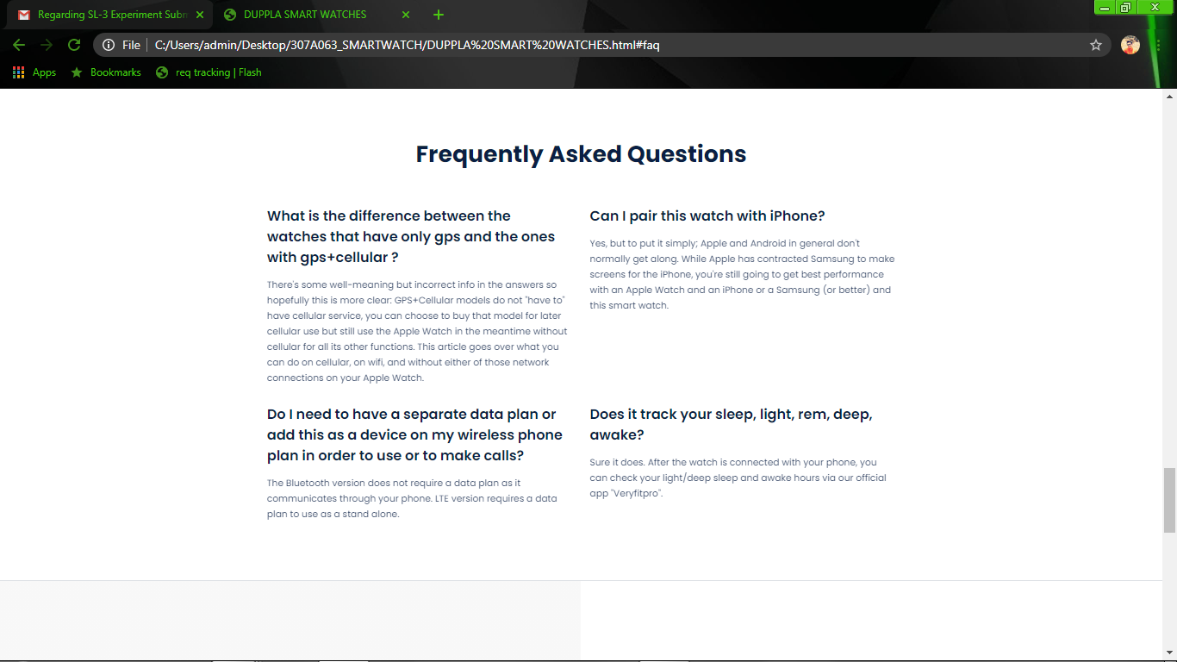

ON CLICKING CONTACT US TAB

